Project Title: NAWI TASK 5.17 - (Salveson, Andy) Data-Driven Fault Detection and Process Control for Potable Reuse with Reverse Osmosis

**PROGRESS AND STATUS BY SUBTASK:**

# **Task: Task 5.17.1** – Desktop Evaluations

## **Task:** **Subtask 5.17.1.5 –** Data-Driven Model Optimization (DDMO) for Chloramine and Anti-Scalant Dosing

**Subtask Lead: Steve Hayden**

Research Questions:

* How much cost and energy could be saved across the reuse treatment train applying DDMO to adjust the pre-chloramine and antiscalant doses and predict a fault in real-time in response to water quality changes?

**PROGRESS AND STATUS:**

* Collected data from:
  + Las Virgenes Municipal Water District
    - All necessary data is available and shared among the team
  + Orange County Water District
    - All necessary data is available and shared among the team
  + West Basin Municipal Water District
    - Additional data from WBMWD is still needed.

### Budget Spent (YCA)

### Summary

In Task 5.17.1.5, data driven model optimization is used to optimize chemicals dosing for RO membrane system and Title 22 filter. In this report, we update the progresses in the process data analysis for the model creation based on the full-scale plant in OCWD, the pilot plant in LVMWD, and the full-scale plant WBMWD.

OCWD is measuring trace chemicals in the RO feed and permeate by Xact 920, which documents the trace chemicals passage across RO and thus informs the RO membrane scaling for RO stages 1, 2, and 3. We completed data preprocessing including temperature correction and are working on prediction of salt passage in terms of conductivity and the chemical equilibrium concentration polarization using Xact 920 data. The inhibitor (anti-scalant) is subject to optimize to prevent scaling and to maintain RO permeability as well as salt passage.

LVMWD adopts TMG10D RO membranes (Toray), and we completed exchanging data into temperature correction data using Toray’s software to understand the general performance trends. We are working on prediction of water qualities such as conductivity, and TOC. In the model creation, we considered head loss at TO membrane behavior as a function of total chlorine concentration detect. Reduce operating costs by optimizing drive pressure while reducing chlorine dependency.

WBMWD receives secondary effluent from the City of Los Angeles’s Hyperion Water Reclamation Plant to produce recycled water for industrial, irrigation, and boiler feed. We received data from WBMWD and completed data preprocessing. In this analysis, we are working on data analysis focusing on effluent turbidity against Title 22 criteria from the Title 22 filter and ferric chloride and cationic polymer are subject to optimize to save chemical dosage.

### Desktop Evaluation based on OCWD

#### Water Quality Prediction

We received data measured at 30-minute intervals in RO B01 unit from OCWD. The RO system configuration of OCWD can be found in Additional Materials A1. RO permeate electric conductivity (EC) and TOC, which are considered an indicator of RO membrane scaling, is focused to predict the behavior based on the statistical model. Each permeate EC is measured at each stage permeate in B01 unit and permeate TOC is measured at the whole RO permeate.

* Data Preprocessing

We used continuous data from May 13th 2022 to November 18th 2022 and excluded data from other periods because it contains data that is not properly measured or significantly different trends.

There are many noise components in the received raw data. The data preprocessing for them was needed before data analysis. Figure 1.1 shows a summary diagram of the data preprocessing. The flow chart in Figure 1.1 explains the data preprocessing approach including the outlier filtering, the noisy data imputation, and the missing data imputation. The outlier filtering is to remove outlier data by imposing upper-lower bounds as a first step. The noisy data imputation is to replace noisy data with alternative data in the time series data by using Hample filter with 96 window steps. Hample filter detects data exceeding confidence interval in given windows as noisy data and replaces the median in given windows as alternative data. The missing data imputation is to fill missing raw data by copying previous and next actual data. We converted the chemical dosing usage data with total daily interval into 30-minute interval data by dividing 48 steps.

Permeate EC [$μS/cm$] at each stage and permeate TOC from May 2022 to November 2022 are plotted with raw data and the preprocessed in Figure 1.2 (a)-(h). By preprocessing the data, outliers are removed, and the data behavior can be extracted.

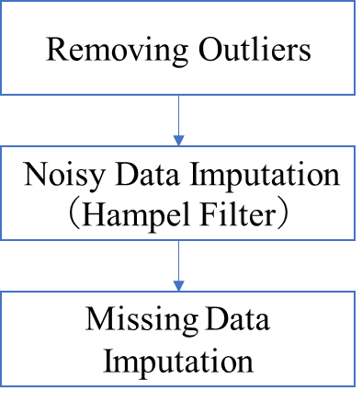

**Figure 1.1: Data Preprocessing Flow Chart (OCWD)**

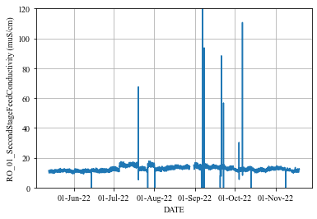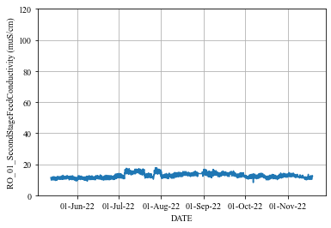

**(a): 1st Stage Raw Conductivity (b): 1st Stage Preprocessed Conductivity**

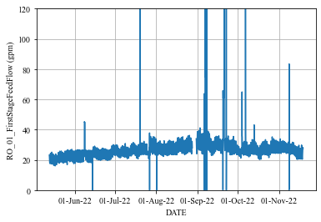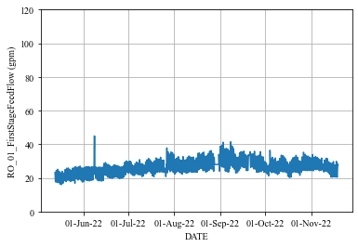

**(c): 2nd Stage Raw Conductivity (d): 2nd Stage Preprocessed Conductivity**

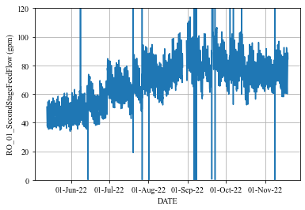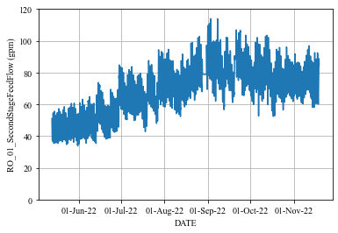

**(e): 3rd Stage Raw Conductivity (f): 3rd Stage Preprocessed Conductivity**



**(g): Permeate Raw TOC (h): Permeate Preprocessed TOC**

**Figure 1.2: Raw and Preprocessed Data of Permeate Conductivity in Each RO Stage and Permeate TOC (OCWD)**

* Water Quality Prediction Model
* Mathematical Prediction Model

We constructed four models for permeate EC at 1st, 2nd, and 3rd stage and permeate TOC at the whole RO. The prediction model is based on the multiple linear regression (MLR), which is statistical model. The mathematical model of MLR is shown as follows:

$$\begin{aligned}y=w_{1}x_{1}+w_{2}x_{2}+…+w_{M}x_{M}+w_{0}\#\left(1.1\right)\end{aligned}$$

Here, $x_{j}$ ($j=1,2,…,M$) denotes explanatory variable, $y$ denotes predictive variable, $w_{j}$ ($j=1,2,…,M$) denotes coefficient parameter, and $w_{0}$ denotes bias parameter. The parameters $w_{j}$ and the standard coefficients are estimated by actual data in the training period. The standard coefficients mean relative contribution of each variable $x_{j}$ for prediction $y$. The estimated parameters can be found in Additional Materials A3.

Table 1.1 shows the variable list for each water quality prediction model. “X” means explanatory variable, “Y” means predictive variable, and “*” means calculated variable. Tag name list is shown in Additional Materials A1.

The calculated 1st stage feed flow rate $Q_{1, feed}$, 2nd stage feed flow rate $Q_{2, feed}$, 3rd stage feed flow rate $Q_{3, feed}$ are shown in below:

$$\begin{aligned}Q_{1, feed }=Q_{1, perm}+Q_{2, perm}+Q_{3, perm}+Q_{3, conc}\#\left(1.2\right)\end{aligned}$$

$$\begin{aligned}Q_{2, feed }=Q_{1, feed }-Q_{1,perm}\#\left(1.3\right)\end{aligned}$$

$$\begin{aligned}Q_{3, feed }=Q_{2, feed }-Q_{2, perm }\#\left(1.4\right)\end{aligned}$$

Here, $Q_{i, perm},Q_{i, conc}$ denotes permeate and concentrate flow rate at stage $i=1,2,3$.

The law of conservation of mass is established around each RO stage. Based on the low, the 2nd stage feed EC ${EC}_{2, feed}$ and 3rd stage feed EC ${EC}_{3, feed}$ are calculated using following equations:

$$\begin{aligned}{EC}_{2, feed}=\frac{Q_{1, feed}×{EC}_{1, feed}+Q_{1, perm}×{EC}_{1, perm}}{Q_{1, feed}-Q_{1, perm}}\#\left(1.5\right)\end{aligned}$$

$$\begin{aligned}{EC}_{3, feed }=\frac{Q_{2, feed}×{EC}_{2, feed}+Q_{2, perm}×{EC}_{2, perm}}{Q_{2, feed}-Q_{2, perm}}\#\left(1.6\right)\end{aligned}$$

In the optimization phase, we need to predict permeate EC ${EC}_{1, perm},{EC}_{2, perm}$ by the prediction model and calculate next stage feed EC ${EC}_{2, feed},{EC}_{3, feed}$ in the prediction period by using the above equations and predicted permeate EC.

**Table 1.1: Variable List in Water Quality Prediction Model (OCWD)**

|  |  |  |  |  |
| --- | --- | --- | --- | --- |
| Variable Name | Stage1 Permeate EC | Stage2 Permeate EC | Stage3 Permeate EC | Permeate TOC |
| RO B01 Feed Pressure | X |  |  | X |
| RO Feed EC | X |  |  | X |
| RO Feed Flow Rate * | X |  |  | X |
| RO Feed Temperature | X | X | X | X |
| RO Feed pH | X |  |  | X |
| Sulfuric Acid Usage | X | X | X | X |
| Threshold Inhibitor Usage | X | X | X | X |
| RO B01 Stage 2 Feed Pressure |  | X |  | X |
| RO B01 Stage 2 Feed EC * |  | X |  |  |
| RO B01 Stage 2 Feed Flow Rate * |  | X |  |  |
| RO B01 Stage 3 Feed EC * |  |  | X |  |
| RO B01 Stage 3 Feed Flow Rate * |  |  | X |  |
| RO Feed TOC |  |  |  | X |
| RO B01 Stage 1 Permeate EC | Y |  |  |  |
| RO B01 Stage 2 Permeate EC |  | Y |  |  |
| RO B01 Stage 3 Permeate EC |  |  | Y |  |
| RO Permeate TOC |  |  |  | Y |

* Training and Period Term

We conducted sequential prediction by linear model and evaluated from May 2022 to November 2022. Figure 1.3 shows overview of sequential prediction and Table 1.2 shows training and prediction period in each term.

For example, training period is from May 13th to May 19th, 2022 (1week) and prediction period is from May 20th to May 27th, 2022 (1week) in the first term. In the next term, we slide these periods to 1week later and conduct re-training (model re-tuning). Therefore, the size of training data set is $30×24×7=5040$ and the size of prediction data set is $30×24×7=5040$ in the single term.

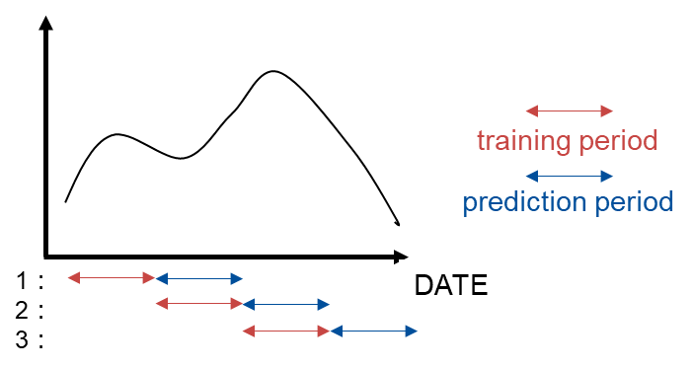

**Figure 1.3: Overview of Sequential Prediction**

**Table 1.2: Training and Prediction Period in Each Term**

|  |  |  |
| --- | --- | --- |
| **Term** | **Trainig Period** | **Prediction Period** |
| 1 | from May 13th to May 19th, 2022 | from May 20th to May 26th, 2022 |
| 2 | from May 20th to May 26th, 2022 | from May 27th to Jun. 2nd, 2022 |
| $$⋮$$ | $$⋮$$ | $$⋮$$ |
| 27 | from Oct. 28th to Nov. 3rd, 2022 | from Nov. 4th to Nov. 10th, 2022 |
| 28 | from Nov. 4th to Nov. 10th, 2022 | from Nov. 11th to Nov. 17th, 2022 |

* Prediction Evaluation Index

The evaluation indexes are Mean Absolute Percentage Error (MAPE) $E_{MAPE}$ [%] and Root Mean Percentage Error (RMSE) $E_{RMSE}$. MAPE indicates a relative prediction error and RMSE is an absolute prediction error. They are calculated between actual data and predicted data in the prediction period. Their mathematical definition can be found in Additional Materials A3. But we excluded outlier data in the data preprocessing from evaluation data.

* Predicton Result

Table 1.4 shows prediction accuracy result, Figure 1.4 shows each stage permeate EC and TOC prediction trend chart in all priod, and Figure 1.5 shows prediction trend chart from 10th to 16th June 2022. In Figure 1.4 and Figure 1.5, blue line is preprocessed actual data and red line is prediction data.

From Figure 1.4, the sequential prediction can predict global trend with good accuracy. From Figure 1.5, the model also can predict periodic fluctuations of EC.

But there is big changes of 1st stage permeate EC actual data in the period from July to August 2022, which is drawn in gray region in Figure 1.4 (a). The sequential prediction during this period is difficult since data characteristics differ significantly between training and prediction period.

**Table 1.4: Prediction Accuracy Result (OCWD)**

|  |  |  |  |  |
| --- | --- | --- | --- | --- |
| **Index** | **Stage1 Permeate EC** | **Stage2 Permeate EC** | **Stage3 Permeate EC** | **Permeate TOC** |
| **RMSE** | 2.28 [uS/cm] | 6.26 [uS/cm] | 15.25 [uS/cm] | 0.014 [ppm] |
| **MAPE** | 10.33 [%] | 13.40 [%] | 15.59 [%] | 12.75 [%] |



**(a): 1st Stage Permeate Conductivity**

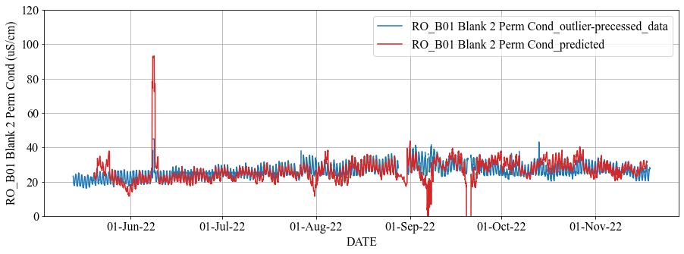

**(b): 2nd Stage Permeate Conductivity**

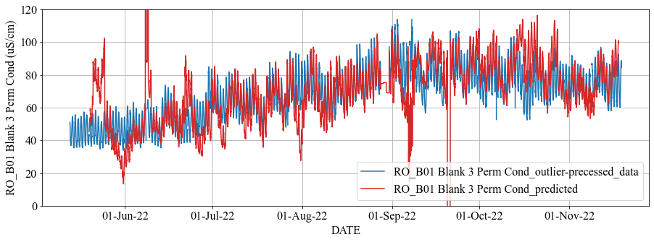

**(c): 3rd Stage Permeate Conductivity**

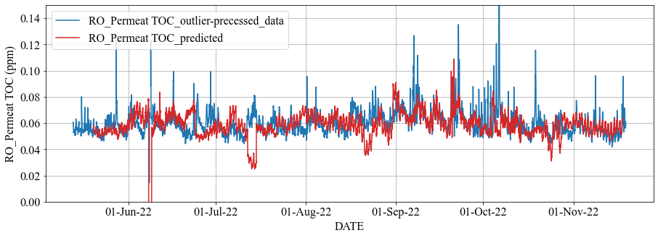

**(d): Permeate TOC**

**Figure 1.4: Prediction Trend in All Period (OCWD)**

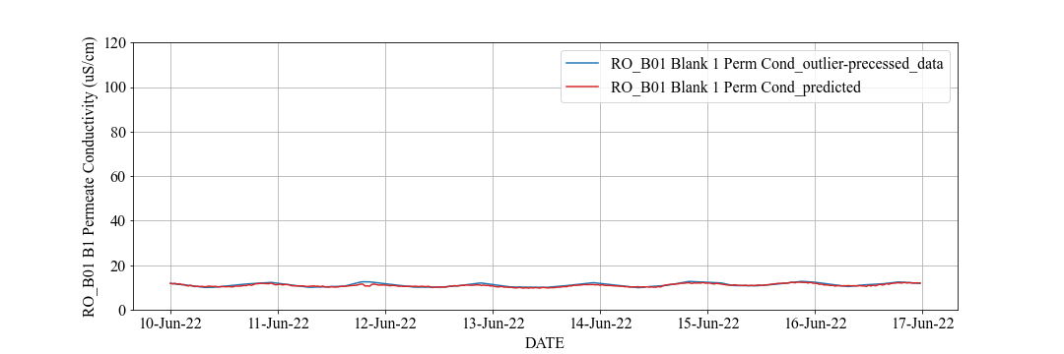

**(a): 1st Stage Permeate Conductivity**

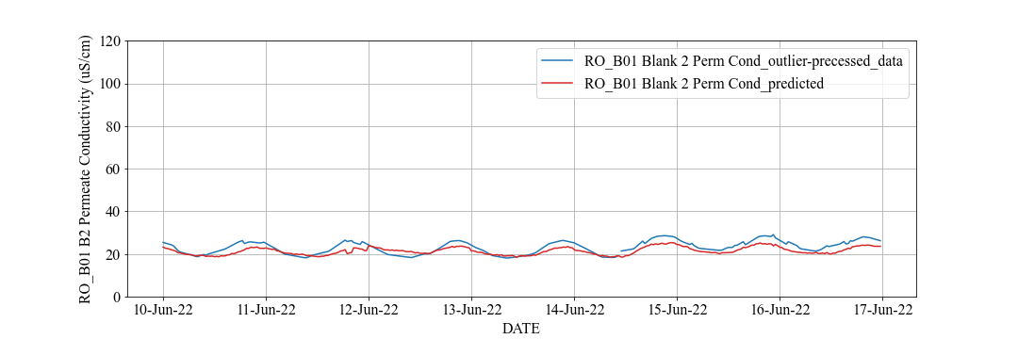

**(b): 2nd Stage Permeate Conductivity**

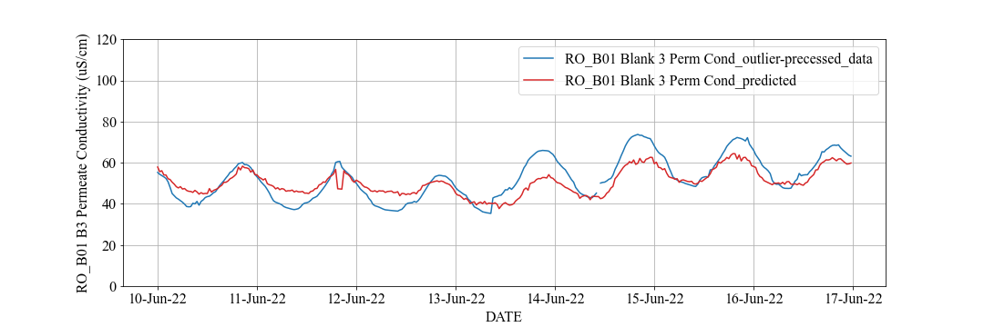

**(c): 3rd Stage Permeate Conductivity**

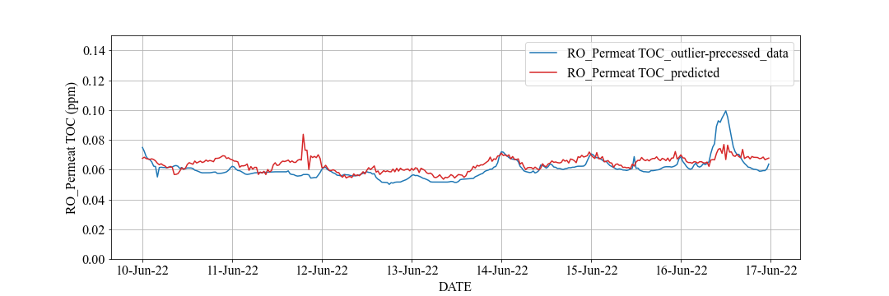

**(d): Permeate TOC**

**Figure 1.5: Prediction Trend from 10th to 16th June 2022 (OCWD)**

Figure 1.6 shows each standard coefficient trend chart of 1st stage permeate EC and TOC prediction model, which is calculated by using Equation (A3). In Figure 1.6, the thorizontal axis is start date of each term (1week) in sequential prediction and each color coressponds to coefficient of each explanatory variable. They are relative contribution of each variable for prediction.

In Figure 1.6, the coefficient of RO feed EC (orange line in Figure 1.6 (a)) and RO feed TOC (orange line in Figure 1.6 (b)) are positive and large value in all period. Therefore, feed EC has a significant impact on permeate EC prediction and feed TOC has a significant impact on permeate TOC prediction based on MLR.

On the oher hand, the coefficients of feed flow rate (gray line in Figure 1.6 (a) and yellow line in Figure 1.6 (b)) and feed pH (light blue line in Figure 1.6 (a) and green line in Figure 1.6 (b)) are very small in all period. Therefore, feed flow rate and feed pH has little impact on permeate EC and TOC prediction based on MLR.

Figure 1.7 shows feed flow rate and feed pH actual data trend chart in the all period. Feed flow rate is constant at 4080 [gpm] and feed pH is constant at 6.9. For this reason, they have little impact on permeate EC and TOC prediction.

Moreover, the gray region in Figure 1.6 (a) coressponds to July 2022. The coefficients of sulfuric acid usage (green line) and inhibitor usage (navy blue line) change in the range -0.5 to 0.5 in the period except for the gray region while they significally change in the gray region. This result explains that 1st permeate EC prediction performance deteriorates in the gray region in the Figure 1.4 (a).



**(a): 1st Stage Permeate Conductivity**

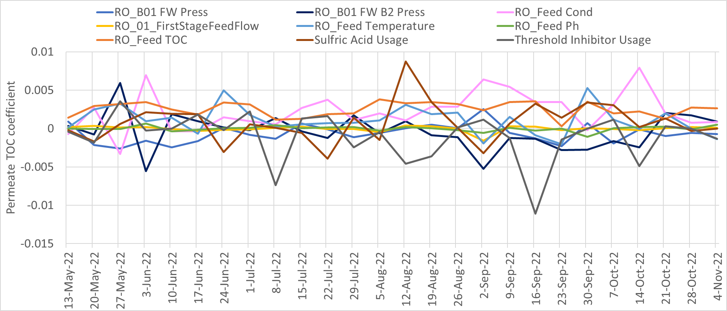

**(b): Permeate TOC**

**Figure 1.6: Standard Coefficients of Prediction Model Trend in All Period (OCWD)**

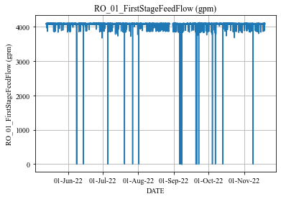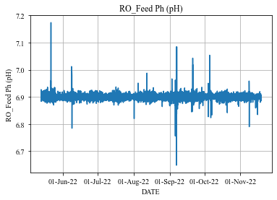

**(a): 1st Stage Feed Flow Rate (b): Feed pH**

**Figure 1.7: Actual Data Trend in RO Feed (OCWD)**

* Future Task

From the results, the sequential prediction based on MLR can predict global trends during most of the period with good accuracy but cannot predict a significant change enough during such as the gray region in Figure 1.4 (a).

From Figure 1.6 (a), the coefficients of the optimization variable (e.g., sulfuric acid usage and threshold inhibitor usage) are small and its positive and negative values are reversed depending on the period. This has negative effects on RO optimization simulation. We should improve the relationship between the chemical dosing and water quality in the prediction model by selecting the specific training period or applying appropriate data preprocessing.

Moreover, sometimes there are sudden and significant changes in prediction value in Figure 1.4. To deal with this, it is considered their values are corrected to the appropriate range (e.g., confidence interval) after MLR based prediction.

#### RO Membrane Scaling using Xact Data

* Summary

We will estimate the potential of scaling by analyzing the concentration of minerals at the surface of RO membranes and solubility of them. The concentration at the surface is generally different from that of the feed water due to concentration gradient around the interface between a membrane and solution caused by selective transfer of water and solutes. This is called as concentration polarization.

The optimal amount of chemical dosing can be calculated by comparing the solubility and concentration at the surface of the membrane. The method to calculate the concentration polarization is described in this report.

* Method to Calculate Concentration Polarization

Concentration polarization is calculated in the following steps.

* + Calculate osmotic pressure across a membrane
  + Calculate permeate flux from driving and osmotic pressures
  + Calculate mass transfer coefficient from osmotic pressure and permeate flux
  + Calculate concentration at the surface from mass transfer coefficient and feed/permeate concentration

First, osmotic pressure is calculated. Van’t Hoff equation holds between osmotic pressure $π_{i,j,k}$ and concentration $C_{i,j,k}$ as shown in the following equation:

$$\begin{aligned}π_{i,j,k}=C_{i,j,k}RT\#\left(1.7\right)\end{aligned}$$

, where $R$ is the gas constant, $T$ is the temperature, and subscripts “ $i,j,k$” denotes RO stage number, locations (feed, membrane surface, permeate), and solutes respectively.

We need know $π_{i,j,k}$ for each location “ $j$”, but some values to calculate them are not measured online. For example, concentration at the membrane surface and concentration of 2nd stage feed and brine are not available. Thus, we assumed the following for those values.

* The concentration at the surface of membrane is the same with that of the feed (as a tentative value during the calculation).
* The concentration of the feed to $i$-th stage is the same with that of the brine from $(i-1)$-th stage.
* The concentration of the feed to the 1st stage and those of the permeate from all stages are measured by Xact.
* The concentration at unmeasured points is calculated by the following equation:
$$\begin{aligned}C_{i,j,k}=Feed Xact data_{k}*\frac{ EC_{i,j}}{EC_{1,feed}}\#\left(1.8\right)\end{aligned}$$

* The electric conductivities ${EC}_{i,conc}$ at unmeasured points are calculated by Figure 1.8 and the following equation: $$\begin{aligned}{EC}_{i,conc}= \frac{Q_{i,feed} ×{EC}_{i,feed}-Q_{i,perm}×{EC}_{i,perm}}{Q_{i,feed} -Q_{i,perm}};i=1,2,3\#\left(1.9\right)\end{aligned}$$ 
  Here, $Q_{i,feed},Q_{i,perm}$ is feed and permeate flow rate at $i$-th stage and ${EC}_{i,feed},{EC}_{i,perm}$ is feed and permeate electric conductivity at $i$-th stage.

Next, permeate flux is calculated. The fluxes of solvent ${J_{v}}_{solv_{i}}$ and solutes ${J_{v}}_{salt_{i,k}}$ are calculated by Equations (1.4) and (1.5) respectively, where $k_{w}$ is the permeability coefficient of pure water. $${J_{v}}_{solv_{i}}=k_{w}*∆P_{i} \\ \begin{aligned}=k_{w}*\left(i th stage feed pressure-i th stage permeate pressure \right)\#\left(1.10\right)\end{aligned}$$

$$\begin{aligned}{J_{v}}_{salt_{i,k}}=k_{w}*\left\{∆P-\left(π_{i,M,k}-π_{i,B,k}\right)\right\}\#\left(1.11\right)\end{aligned}$$

Mass transfer coefficients $k_{i,k}$ for solute $k$ at stage $i$ are calculated by Equations (1.9), (1.10), and (1.11). $$\begin{aligned}k_{i,k}=\frac{{J_{v}}_{salt_{i,k}}}{\log\left(\frac{∆P_{i}}{π_{i,B,k}-π_{i,P,k}}*\left(1-\frac{{J_{v}}_{salt_{i,k}}}{{J_{v}}_{solv_{i}}}\right)\right)}\#\left(1.12\right)\end{aligned}$$

The concentration at the membrane surface is calculated by Equation (1.13). $$\begin{aligned}C_{i,M,k}=\left(C_{i,B,k}-C_{i,P,k}\right)×e^{\frac{{J_{V}}_{solv_{i}}}{k_{i,k}}}+C_{i,P,k}\#\left(1.13\right)\end{aligned}$$

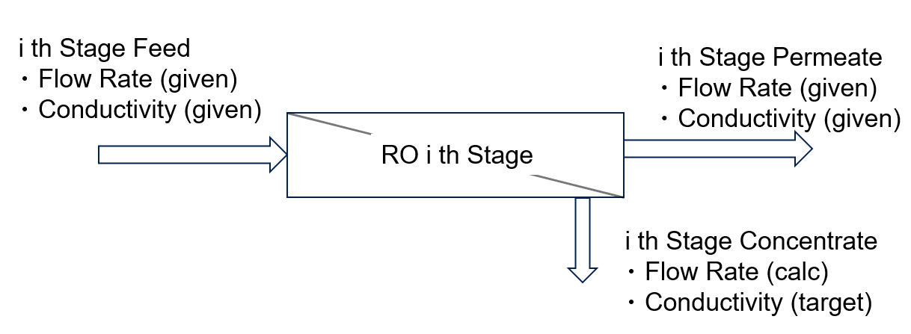

**Figure 1.8: Flow Rates and Conductivities From / To Each Stage**

* Results

The membrane surface concentration calculated by Equation (1.13) is shown in Figure 1.9. Figure 1.9 (a) shows the membrane surface concentration of Ca and Figure 1.9 (b) shows that of Si. The left axis is for the 1st stage concentration and the right is for the 3rd. For each stage, salts are about 150 to 200% concentrated at membrane surface (solid line) compared to feed (dashed line). The concentration at the 3rd stage is higher than the 1st, thus the result shows that the concentration process can be simulated where the salts are concentrated with each stage

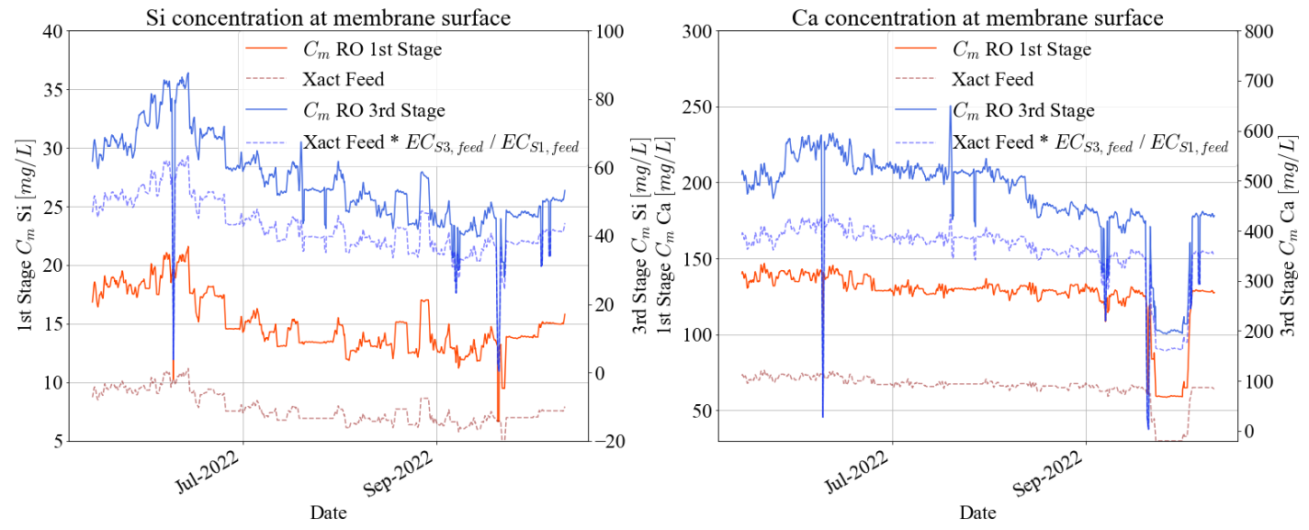

**(a): Si concentration (b): Ca concentration**

**Figure 1.9: Comparison of Concentrations Between Feed and Membrane Surface**

**(The 1st and 3rd Stages Are Plotted)**

* Future Work

The goal of this study is to provide guidance of the amount of anti-scalant dosing. To archive that, we will use the estimated concentration at the membrane surfaces to decide if minerals (mainly Si and Ca) will deposit on the membrane surface considering solubility equilibrium. The typical form of the equilibrium equation is shown in Equation (1.14) and we will use specialized software[1] to calculate the solubility of minerals at the given conditions. $$\begin{aligned}aA+bB↔cC+dD\#\left(1.14\right)\end{aligned}$$  
For example, the equilibrium equation for calcium sulfate, the cause of scaling, is as follows. $$\begin{aligned} CaSO_{4}↔Ca^{2+}+SO_{4}^{2-}\#\left(1.15\right)\end{aligned}$$

The final outcome will be a model to calculate the optimal amount of anti-scalant considering the concentration and solubility.

#### RO Optimization Simulation Model

* Summary

We formulated RO optimization problem for OCWD and constructed a RO optimization simulation model implemented by the water quality prediction or scaling model. We will carry out the optimization simulation and calculate an improvement effect compared actual operation in the past period in the final report.

* RO Optimization Problem for OCWD

Basic optimization story for OCWD is to decrease the chemical dosing cost (e.g., sulfuric acid or inhibitor) while satisfying water quality standards or monitoring a RO membrane scaling. Considering the above story, we formulated the RO optimization problem for OCWD.

* Scheduling Problem

RO optimization is to improve the operation in some period of time. This type of optimization problem is the scheduling problem, which is formulated and solved according to procedure as shown in Figure 1.10. The procedure consists of drawing flow chart, formulation mathematical optimization problem, and calculation operational schedule. Therefore, drawing a flow chart, variable, objective function, and constraint condition are required to construct a simulation model.

The operational schedule structure is shown as Table 1.5. $x_{i}\left[t\right]$ denotes the $i$-th variable schedule at time $t$, $x_{i}=(x_{i}\left[1\right], x_{i}\left[2\right],…, x_{i}\left[L\right])$ denotes the $i$-th variable schedule in all period, $X=(x_{1},x_{2},…,x_{n})$ denotes all variables schedule in all period, $L$ denotes the length (step size) of the optimization period, and $n$ denotes the number of variables, respectively. For example, if the optimization period is 1 week of 30 minutes time interval data (e.g., 0:30, 1:00. 1:30, 2:00, …), we can estimate $L=(60/30)×24×7=336$ step.



**Figure 1.10: Procedure for Solving Scheduling Problem**

**Table 1.5: Operational Schedule Structure**

|  |  |  |  |  |
| --- | --- | --- | --- | --- |
|  | $$x_{1}[t]$$ | $$x_{2}[t]$$ | $$⋯$$ | $$x_{n}[t]$$ |
| $$t=1$$ | $$x_{1}[1]$$ | $$x_{2}[1]$$ | $$⋯$$ | $$x_{n}[1]$$ |
| $$t=2$$ | $$x_{1}[2]$$ | $$x_{2}[2]$$ | $$⋯$$ | $$x_{n}[2]$$ |
| $$⋯$$ | $$⋯$$ | $$⋯$$ | $$⋯$$ | $$⋯$$ |
| $$t=L$$ | $$x_{1}[L]$$ | $$x_{2}[L]$$ | $$⋯$$ | $$x_{n}[L]$$ |

* Flow Chart

Figure 1.11 shows the flow chart for OCWD based on the RO system configuration. The RO system configuration of OCWD can be found in Additional Materials A1. Figure 1.11 (a) is the flow chart limited to the part related to permeate TOC prediction and Figure 1.11 (b) is the flow chart limited to the part related to permeate EC prediction.

In Figure 1.11, arrows connecting objects are assigned variables. The classification of each variable (e.g., optimization variable or fixed variable) is described below. The storage object means exogenous variable, the hexagon object means mathematical model, and the square object means predictive variable (e.g., water quality data). The arrow toward the object is input data and the arrow out from the object is output data. The color of arrows is different for each object to which it is connected. Especially, mathematical models have both input and output data. Output data from the hexagon object toward the square object is calculated by the prediction model in the previous section.



1. **RO Total Flow Chart (Permeate TOC)**



1. **RO Each Stage Flow Chart (Permeate EC)**

**Figure 1.11: Flow Chart for RO Optimization Simulation (OCWD)**

* Mathematical Optimization Problem

Mathematical optimization problem is formulated as minimizing $f(x)$ such that constraints $g_{κ}\left(x\right)≤0$ ($κ=1,2,…,K$), where $x∈R^{N}$ denotes the optimization variable, $f:R^{N}→R$ denotes the objective function (cost function), $g_{κ}:R^{N}→R$ denote $K$ constraint functions, $R$ denotes the set of real numbers, $N$ denotes the number of total variables, respectively.

Optimization variable list is as shown in Table 1.6. “Optimization Variable” means cost or manipulated variable (chemical dose), “Fixed Parameter” is given by actual value, “Intermediate Variable” indirectly affects the objective function or constraints in the calculation (e.g., prediction value). In OCWD optimization model, “Optimization Variable” is “Sulfuric Acid Usage” and “Threshold Inhibitor Usage” and the number of the optimization variables $n=2$.

**Table 1.6: Optimization Variable List (OCWD)**

|  |  |  |  |
| --- | --- | --- | --- |
| ID No. | Description | Unit | Opt. Variable / Fixed Parameter |
| ID0000 | Sulfuric Acid Usage | ton/day | Optimization Variable |
| ID0001 | Threshold Inhibitor Usage | ton/day | Optimization Variable |
| ID0002 | Feed EC | $$μS/cm$$ | Fixed Parameter |
| ID0003 | Feed TOC | ppm | Fixed Parameter |
| ID0004 | Feed Temperature | $$℉$$ | Fixed Parameter |
| ID0005 | Feed pH | - | Fixed Parameter |
| ID0100 | Stage 1 Feed Pressure | psi | Fixed Parameter |
| ID0101 | Stage 1 Feed Flow Rate | gpm | Fixed Parameter |
| ID0102 | Stage 1 Permeate Flow Rate | gpm | Fixed Parameter |
| ID0200 | Stage 2 Feed Pressure | psi | Fixed Parameter |
| ID0201 | Stage 2 Feed Flow Rate | gpm | Fixed Parameter |
| ID0202 | Stage 2 Permeate Flow Rate | gpm | Fixed Parameter |
| ID0300 | Stage 3 Feed Flow Rate | gpm | Fixed Parameter |
| ID1000 | Stage 1 Permeate EC | $$μS/cm$$ | Intermediate Variable |
| ID2000 | Stage 2 Feed EC | $$μS/cm$$ | Intermediate Variable |
| ID2001 | Stage 2 Permeate EC |  | Intermediate Variable |
| ID3000 | Stage 3 Feed EC | $$μS/cm$$ | Intermediate Variable |
| ID3001 | Stage 3 Permeate EC | $$μS/cm$$ | Intermediate Variable |
| ID4000 | Permeate TOC | ppm | Intermediate Variable |

The objective function $f(x)$ is formulated as follows:

$$\begin{aligned}f(x) =\sum_{t=1}^{L}{(c_{1}x_{ID0000}\left[t\right]+c_{2}x_{ID0001}\left[t\right])}\#\left(1.16\right)\end{aligned}$$

Here, $x_{ID0000}\left[t\right]$ denotes threshold inhibitor usage at time $t$, $x_{ID0001}\left[t\right]$ denotes the sulfuric acid usage at time $t$, $c_{1},c_{2}$ denotes cost coefficients, and $L$ denotes the length (step size) of optimization period, respectively.

Constraint conditions are as following:

$$\begin{aligned}0≤x_{ID0000}\left[t\right]≤12; t=1,2,…,L\#\left(1.17\right)\end{aligned}$$

$$\begin{aligned}0≤x_{ID0001}\left[t\right]≤4; t=1,2,…,L\#\left(1.18\right)\end{aligned}$$

$$\begin{aligned}10≤x_{ID1000}\left[t\right]≤95; t=1,2,…,L\#\left(1.19\right)\end{aligned}$$

$$\begin{aligned}20≤x_{ID2001}\left[t\right]≤200; t=1,2,…,L\#\left(1.20\right)\end{aligned}$$

$$\begin{aligned}60≤x_{ID3001}\left[t\right]≤350; t=1,2,…,L\#\left(1.21\right)\end{aligned}$$

$$\begin{aligned}0≤x_{ID4000}\left[t\right]≤0.15; t=1,2,…,L\#\left(1.22\right)\end{aligned}$$

$$\begin{aligned}-1≤x_{ID0000}\left[t\right]-x_{ID0000}\left[t+1\right]≤1; t=1,2,…,L-1\#\left(1.23\right)\end{aligned}$$

$$\begin{aligned}-1≤x_{ID0001}\left[t\right]-x_{ID0001}\left[t+1\right]≤1; t=1,2,…,L-1\#\left(1.24\right)\end{aligned}$$

$$\begin{aligned}1.5≤γ_{ID1000}\left[t\right]≤2.3; t=1,2,…,L\#\left(1.25\right)\end{aligned}$$

$$\begin{aligned}1.5≤γ_{ID2001}\left[t\right]≤2.3; t=1,2,…,L\#\left(1.26\right)\end{aligned}$$

$$\begin{aligned}1.5≤γ_{ID3001}\left[t\right]≤2.3; t=1,2,…,L\#\left(1.27\right)\end{aligned}$$

$$\begin{aligned}1.5≤γ_{ID4000}\left[t\right]≤2.5; t=1,2,…,L\#\left(1.28\right)\end{aligned}$$

Here, Equations (1.17), (1.18), (1.19), (1.20), (1.21), (1.22) denotes lower and upper limit, Equations (1.23), (1.24) denotes fluctuation range limit, Equations (1.25), (1.26), (1.27), (1.28) denotes water quality standards limit based on LRV, respectively.

Intermediate variables $x_{ID1000}\left[t\right]$ (Stage1 permeate conductivity), $x_{ID2001}\left[t\right]$ (Stage2 permeate conductivity), $, x_{ID3001}\left[t\right]$ (Stage3 permeate conductivity), and $x_{ID4000}\left[t\right]$ (permeate TOC) are calculated by water quality prediction model as follows:

$$\begin{aligned}x_{ID1000}\left[t\right]=F_{ID1000}(x_{ID0000}\left[t\right],x_{ID0001}\left[t\right],x_{ID0002}\left[t\right],x_{ID0004}\left[t\right],x_{ID0005}\left[t\right], \\ x_{ID0100}\left[t\right], x_{ID0101}\left[t\right]); t=1,2,…,L\#\left(1.29\right)\end{aligned}$$

$$\begin{aligned}x_{ID2001}\left[t\right]=F_{ID2001}(x_{ID0000}\left[t\right],x_{ID0001}\left[t\right],x_{ID0004}\left[t\right],x_{ID0200}\left[t\right],x_{ID0201}\left[t\right], \\ x_{ID2000}\left[t\right]); t=1,2,…,L\#\left(1.30\right)\end{aligned}$$

$$\begin{aligned}x_{ID3001}\left[t\right]=F_{ID3001}\left(x_{ID0000}\left[t\right],x_{ID0001}\left[t\right],x_{ID0004}\left[t\right],x_{ID0300}\left[t\right],x_{ID3000}\left[t\right]\right); \\ t=1,2,…,L\#\left(1.31\right)\end{aligned}$$

$$\begin{aligned}x_{ID4000}\left[t\right]=F_{ID4000}(x_{ID0000}\left[t\right],x_{ID0001}\left[t\right],x_{ID0002}\left[t\right], x_{ID0003}\left[t\right],x_{ID0004}\left[t\right], \\ x_{ID0005}\left[t\right],x_{ID0100}\left[t\right], x_{ID0101}\left[t\right], x_{ID0200}\left[t\right]); t=1,2,…,L\#\left(1.32\right)\end{aligned}$$

$γ_{X}$ is Logarithmic Reduction Value (LRV) of water quality data $X$ (e.g., electric conductivity and TOC) as follows:

$$\begin{aligned}γ_{X}\left[t\right]=\log_{10}\left(\frac{X_{feed}[t]}{X_{perm}[t]}\right); t=1,2,…,L\#\left(1.33\right)\end{aligned}$$

Here, $X_{feed}$ denotes feed quality data $X$ and $X_{perm}$ denotes permeate quality data $X$ at each stage.

The scale of the above problem can be roughly estimated such as number of total optimization variables $N=2L$ and number of total constraints . For example, if the optimization period is 1week of 30 minutes time interval data, we can estimate $L=(60/30)×24×7=336$ steps, $N=2×336=672$, and $K=12×336-2=4030$.

* Optimization Algorithm

The above problem is classified as constrained and black-box problem. We constructed and used an optimization algorithm by combining SHADE[2] and Feasibility Rule[3] for solving the problem. SHADE is known to the best unconstrained black-box optimization in the optimization field recently and often used in the BBOB competition[4]. Feasibility Rule is one of the constraint handling techniques, which enable unconstrained optimization algorithms to apply to the constrained optimization. We finished to write python source code from scratch and will apply it to the above problem.

### Desktop Evaluation based on LVMWD

#### Water Quality Prediction

We received data measured at 1minute or 1day intervals in RO unit from LVMWD. The RO system configuration of LVMWD can be found in Additional Materials A2. RO permeate electric conductivity (EC) and TOC, which are considered an indicator of RO membrane fouling, is focused to predict the behavior based on the statistical model. Each permeate EC is measured at each stage permeate and permeate TOC is measured at the whole RO permeate.

* Data Preprocessing

We used continuous data from July 1st 2021 to July 27th 2022 and excluded data from other periods because it contains data that is not properly measured or significantly different trends.

There are many noise components in the received raw data. The data preprocessing for them was needed before data analysis. The trend data is converted the chemical dosing usage data with 1minute interval into 30-minute interval data by using the method described in the 2nd quarterly report. After that, the data is preprocessed by using procedure as in the case of OCWD.

* Water Quality Prediction Model

We constucted water quality prediction model for LVMWD. They are MLR as in the case of OCWD model. Table 2.1 shows the variable list for each water quality prediction model. “X” means explanatory variable, “Y” means predictive variable, and “*” means calculated variable. Tag name list is shown in Additional Materials A2.

We conducted sequential prediction by linear model and evaluated from July 2021 to July 2022. Figure 1.3 shows overview of sequential prediction and Table 2.2 shows training and prediction period in each term as in the case of OCWD.

We used MAPE and RMSE as the prediction evaluation index as in the case of OCWD.

**Table 2.2: Training and Prediction Period in Each Term**

|  |  |  |
| --- | --- | --- |
| **Term** | **Trainig Period** | **Prediction Period** |
| 1 | from July 1st to July 7th, 2021 | from July 8th to July 14th, 2021 |
| 2 | from July 8th to July 14th, 2021 | from July 15th to July 21st, 2021 |
| $$⋮$$ | $$⋮$$ | $$⋮$$ |
| 54 | from July 7th to July 13th, 2022 | from July 14th to July 20th, 2022 |
| 55 | from July 14th to July 20th, 2022 | from July 21st to July 27th, 2022 |

**Table 2.1: Variable List of each water quality prediction model (LVMWD)**

|  |  |  |  |  |
| --- | --- | --- | --- | --- |
| Variable Name | Stage1 Permeate EC | Stage2 Permeate EC | Stage3 Permeate EC | Permeate TOC |
| RO Stage 1 Feed Pressure | X |  |  | X |
| RO Feed EC | X |  |  | X |
| RO Feed Flow | X |  |  | X |
| RO Feed Temperature | X | X | X | X |
| RO Feed pH | X |  |  | X |
| UF Filtrate Total Chlorine | X | X | X | X |
| RO Stage 2 Feed EC |  | X |  |  |
| RO Stage 2 Feed Flow |  | X |  |  |
| RO Stage 3 Feed Pressure |  |  | X | X |
| RO Stage 3 Feed EC |  |  | X |  |
| RO Stage 3 Feed Flow |  |  | X |  |
| RO Feed TOC |  |  |  | X |
| RO Stage 1 Permeate EC | Y |  |  |  |
| RO Stage 2 Permeate EC |  | Y |  |  |
| RO Stage 3 Permeate EC |  |  | Y |  |
| RO Combined Permeate TOC |  |  |  | Y |

* Predicton Result

Table 2.3 shows prediction accuracy result, Figure 2.1 shows each stage permeate EC and TOC prediction trend chart in all priod, Figure 2.2 shows prediction trend chart from 29th July to 4th August 2021, and Figure 2.3 shows prediction trend chart from 10th to 17th March 2022. In Figure 2.1, Figure 2.2, and Figure 2.3, blue line is preprocessed actual data and red line is prediction data.

From Figure 2.1, the sequential prediction can predict global trend with good accuracy. From Figure 2.2 and 2,3, the model also can predict periodic fluctuations of EC.

But there is big changes of each stage permeate EC and TOC actual data data in the specific period which is drawn in gray region in Figure 2.1. The sequential prediction during this period is difficult since data characteristics differ significantly between training and prediction period.

**Table 2.3: Prediction Accuracy Result (LVMWD)**

|  |  |  |  |  |
| --- | --- | --- | --- | --- |
| **Index** | **Stage1 Permeate EC** | **Stage2 Permeate EC** | **Stage3 Permeate EC** | **Permeate TOC** |
| **RMSE** | 2.07 [uS/cm] | 2.36 [uS/cm] | 4.63 [uS/cm] | 0.030 [mg/L] |
| **MAPE** | 5.27 [%] | 5.04 [%] | 9.04 [%] | 19.46 [%] |



**(a): 1st Stage Permeate Conductivity**



**(b): 2nd Stage Permeate Conductivity**



**(c): 3rd Stage Permeate Conductivity**



**(d): Permeate TOC**

**Figure 2.1: Prediction Trend in All Period (LVMWD)**

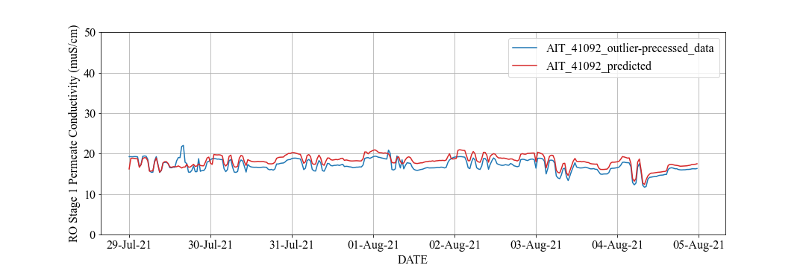

**(a): 1st Stage Permeate Conductivity**

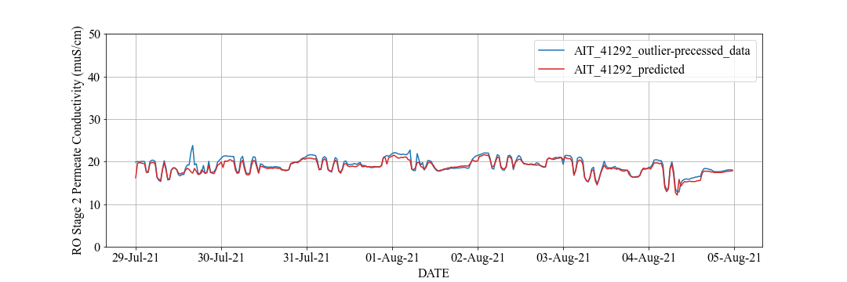

**(b): 2nd Stage Permeate Conductivity**

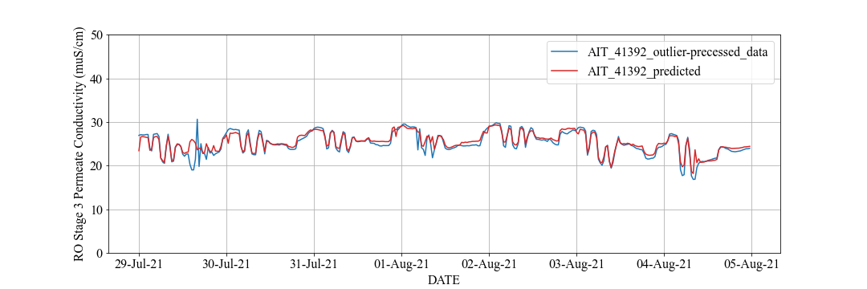

**(c): 3rd Stage Permeate Conductivity**

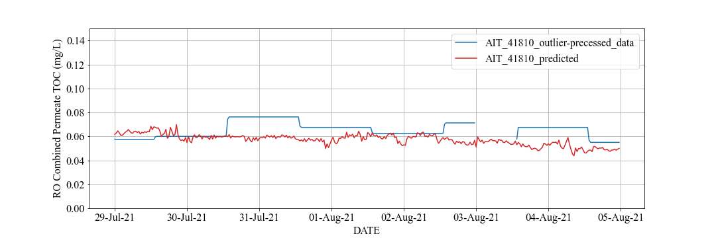

**(d): Permeate TOC**

**Figure 2.2: Prediction Trend from 29th July to 4th August 2021 (LVMWD)**

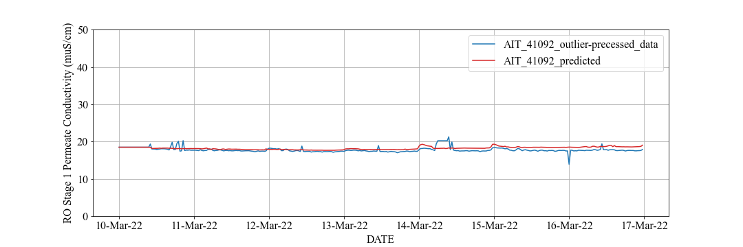

**(a): 1st Stage Permeate Conductivity**

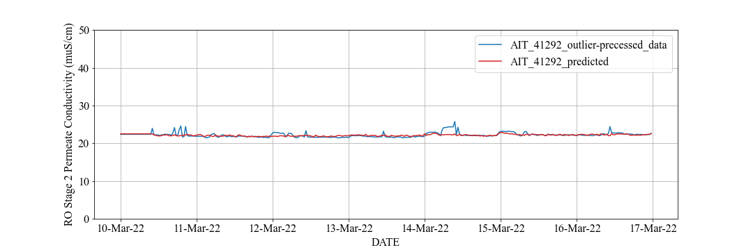

**(b): 2nd Stage Permeate Conductivity**

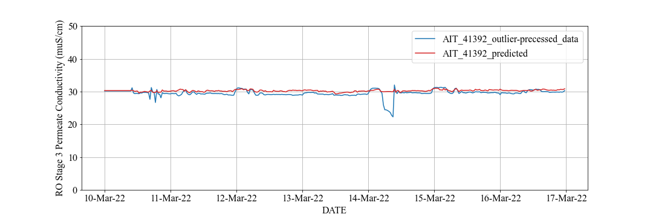

**(c): 3rd Stage Permeate Conductivity**

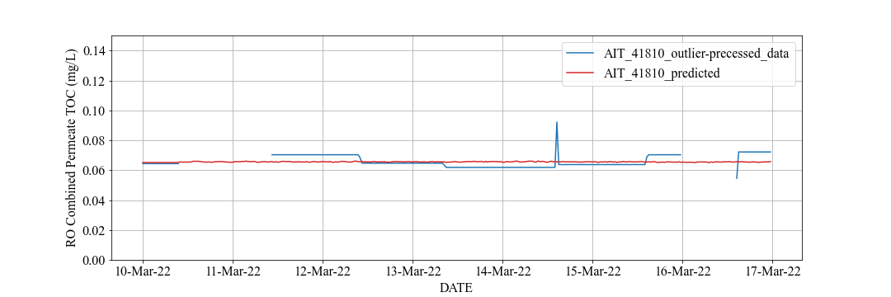

**(d): Permeate TOC**

**Figure 2.3: Prediction Trend from** **10th to 17th March 2022 (LVMWD)**

Figure 2.4 shows RO feed EC, RO feed TOC, and 3rd stage permeate EC actual data trend chart in all period. The gray region in Figure 2.4 coressponds to the gray region in Figure 2.1 and the orange region in Figure 2.4 (c) coressponds to the orange region in Figure 2.1 (c).

In the gray region in Figure 2.4, it is considered the trend of RO permeate water quality prediction has a significant change as RO feed actual data has a siginificant change.

Moreover, the performance of 3rd stage peremate EC prediction deteriorates during the period in the orange region of Figure 2.1 (c). There is a significant change of 3rd stage permeate EC actual data in this period. The sequential prediction during this period is difficult since data characteristics differ significantly between training and prediction period.



**(a): Feed Conductivity (b): Feed TOC**



**(c): 3rd Stage Permeate Conductivity**

**Figure 2.4: Actual Data Trend in RO Feed (LVMWD)**

* Future Task

Measured data of permeate EC and TOC has a significantly change frequently and they should be detected as outlier data. But, it is considered that these data cannot be removed enough by the current preprosessing method. Therefore, future task are to apply a new imputation method to these data and to consider sensor measurement accuracy.

The Kalman Filter[5] is example of new imputation method and widely used in modern control thoery. The result correcting permeate TOC actual data by the Kalman Filter is shown in Figure 2.5. In Figure 2.5, the blue line is TOC trend chart preprocessed by the method in the previous section and the orange line is TOC trend chat preprocessed by the Kalman Filter. Comparing the results, the Kalman Filter has better smoothing of large noise data. This indicates that the new imputation method is effective for outlier correction.

The same issues regarding trends in optimization variables remain as with OCWD.

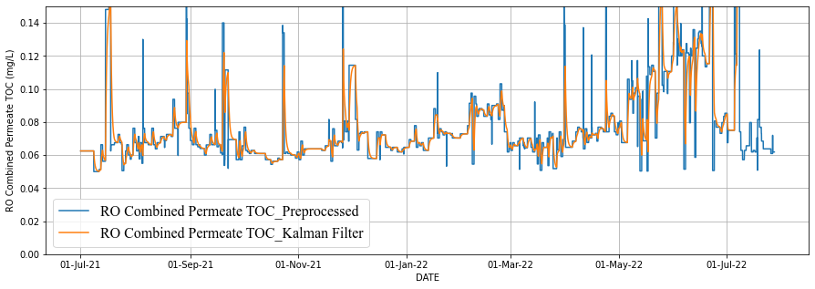

**Figure 2.5: Preprocessed Permeate TOC by Kalman Filter (LVMWD)**

#### RO Membrane Fouling

* Summary

There are two major factors that cause fouling on RO membrane: fluidic and chemical loads. For the former, higher flow rate or pressure place a greater load on the membrane. For the latter, higher concentration of substances in the feedwater places a greater load on the membrane. This report focuses on the physical load.

* Dynamics of Physical Load

Bernoulli’s principle, which can be seen as an energy conservation law in fluid dynamics, is used to estimate the physical load on RO membranes. The law assumes the laminar flow conditions and described as the following equation: $$\begin{aligned}P+\frac{1}{2}ρv^{2}+ρgh=const.\#\left(2.1\right)\end{aligned}$$

, where $P\left[Pa\right]$ is the static pressure, $ρ\left[kg/m^{3}\right]$ is the density, $v\left[m/s\right]$ is the flow speed, $h\left[m\right]$ is the elevation, and $g\left[m/s^{2}\right]$ is the gravitational constant, especially the second term in the left side in Equation (2.1) is called the dynamic pressure $q=ρv^{2}/2[Pa]$.

Figure 2.6 defines the inputs and outputs of an RO system. Assuming the viscous resistance is negligible, the flow is incompressible, and the elevation of the pipes are the same, Equation (2.1) can be transformed as the following equations: $$\begin{aligned}P_{feed}+\frac{1}{2}ρv_{feed}^{2}=P_{perm}+P_{3,conc}+q_{perm}+\frac{1}{2}ρv_{3,conc}^{2}\#\left(2.2\right)\end{aligned}$$

$$\begin{aligned}P_{perm}=P_{1,perm}+P_{2,perm}+P_{3,perm}\#\left(2.3\right)\end{aligned} \\ \begin{aligned}q_{perm}=\frac{1}{2}ρv_{1,perm}^{2}+\frac{1}{2}ρv_{2,perm}^{2}+\frac{1}{2}ρv_{3,perm}^{2}\#\left(2.4\right)\end{aligned}$$

Here, $P_{feed}$ denotes the feed pressure, $v_{feed}$ denotes the feed flow speed, subscripts “ $i,j$” denotes RO stage number, locations (permeate, concentrate), and RO total permeate static pressure $P_{perm}$ and total permeate dynamic pressure $q_{perm}$ are sum of each stage permeate value, respectively.

In an actual RO system, however, Equation (2.2) does not hold because the energy is lost due to the resistance of the membrane. By introducing energy loss due to membrane, denoted by $R_{RO}$, into Equation (2.2), we have an energy conservation equation across a membrane as Equation (2.5). $$\begin{aligned}P_{feed}+\frac{1}{2}ρv_{feed}^{2}=P_{perm}+P_{3,conc}+q_{perm}+\frac{1}{2}ρv_{3,conc}^{2}+R_{RO}\#\left(2.5\right)\end{aligned}$$

Considering that $R_{RO}$ is the energy loss at a membrane, it can be considered as a good explanatory factor to estimate the fouling of the membrane. As the fouling on the membrane progresses, the resistance at the membrane increases and the energy loss $R_{RO}$ increases.

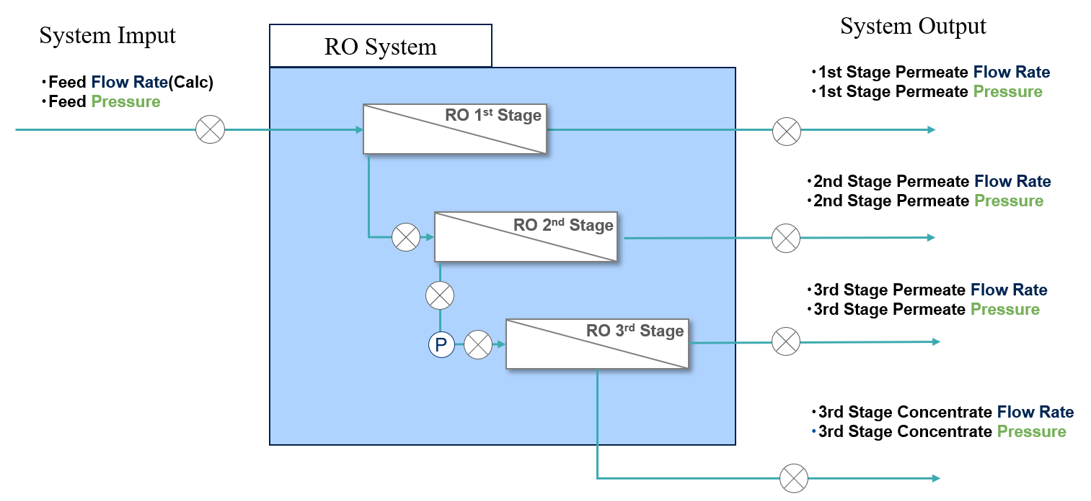

**Figure 2.6: Definition of Inputs/Outputs of RO System**

* Method to Estimate $R_{RO}$

$R_{RO}$ is estimated in the following steps.

* 1. Measured values are converted to fit the variables in Bernoulli’s principle.
  2. Estimate the unknown parameters in Bernoulli’s principle.
  3. Calculate $R_{RO}$ using the estimated parameters.

First, measured values of input/output variables defined in Figure 2.6 are converted so that they can be substituted into Equation (2.5). Conversion of static pressure and flow rate are explained below for an example. In this example, the measured static pressure is denoted by $P$ [psi] and the measured flow rate is denoted by $Q$ [gpm]. The static pressure and flow speed are in Equation (2.5) is given by Equations (2.6) and (2.7). $$\begin{aligned}P_{i,j}\left[Pa\right]=c_{P}×P_{i,j}\left[psi\right]\#\left(2.6\right)\end{aligned}$$

$$\begin{aligned}v_{i,j}\left[m/s\right]=c_{v}×\frac{Q_{i,j}\left[gpm\right]}{a_{i,j}\left[m^{2}\right]} \#\left(2.7\right)\end{aligned}$$

, where $c_{P}=6895,c_{v}=3.7854/(60×1000)$ are unit conversion coefficients, $a[m^{2}]$ is the cross-sectional area of the pipe, subscripts “ $i,j$” denotes RO stage number, locations (permeate, concentrate), respectively.

We do not have the information on the diameters of pipes and if we tentatively assume that all of them has the same diameter $a$, we replace Equation (2.7) with Equation (2.8).

$$\begin{aligned}v_{i,j}\left[m/s\right]=c_{v}×\frac{Q_{i,j}\left[gpm\right]}{a\left[m^{2}\right]} \#\left(2.8\right)\end{aligned}$$

By applying a similar conversion, Equation (2.5) can be transformed to the following equations: $$\begin{aligned}c_{P}\left(P_{1,feed}-P_{perm}-P_{3,conc}\right)= \frac{ρ}{a^{2}}\left\{\frac{c_{v}^{2} }{2}\left(-{Q_{1,feed}}^{2}+{Q_{perm}}^{2}+{Q_{3,conc}}^{2}\right)\right\}+R_{RO}\#\left(2.8\right)\end{aligned} \\ \begin{aligned}{Q_{perm}}^{2}={Q_{1,perm}}^{2}+{Q_{2,perm}}^{2}+{Q_{3,perm}}^{2}\#\left(2.9\right)\end{aligned}$$

There are unknown parameters $ρ/a^{2}$ in Equation (2.8). To estimate it, we assumed $R_{RO}=0$ tentatively and solved $ρ/a^{2}$ by the least-squares method and obtained the result in Figure 2.7. Figure 2.7 (a) shows the result for LVMWD and (b) shows that for OCWD. In all plots, the vertical axis shows the feature values related to flow rates (the right side of Equation (2.8)) and the horizontal one shows those related to pressures (the left side of Equation (2.8)). In both cases of LVMWD and OCWD, we get positive regression coefficients, which is consistent with physical insights that density or density divided by squared area are positive.  
Looking at the scatter plot of LVMWD, it has low correlation and the estimation of $ρ/a^{2}$ is not expected to be accurate. One of the reasons may be that we assumed the diameters of pipes are the same. In OCWD case, the accuracy is known to be improved by considering the diameters of pipes. Figure 2.7 (b) is calculated using pipe diameters described in P&ID and (c) is calculated without that information. Comparing them, (b) has positive correlation and coefficients, while (c) does not. We expect the estimation accuracy in LVMWD will also be improved if the diameters are known.

Finally, we calculated $R_{RO}$ using Equation (2.9) with estimated parameters. Figure 2.8 shows 0-1 normalized values of estimated $R_{RO}$ in the vertical axis and dates in the horizontal axis. The energy loss of the fluid is fluctuating according to the inputs. Derivation of an energy conservation law reflecting mass on the RO system output and consideration of booster pump dynamics are future works.

* Future Task

Future tasks are (i) the estimation accuracy improvement if the diameters are known; (ii) derivation of an energy conservation law reflecting mass on the RO system output and consideration of booster pump dynamics.

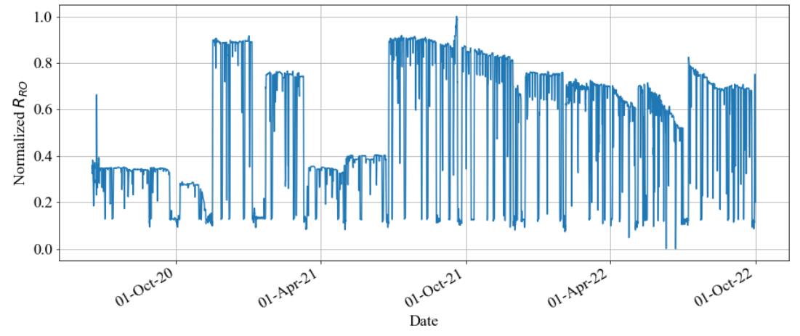

**Figure 2.8: Estimated $R_{RO}$**  **Trend Chart**

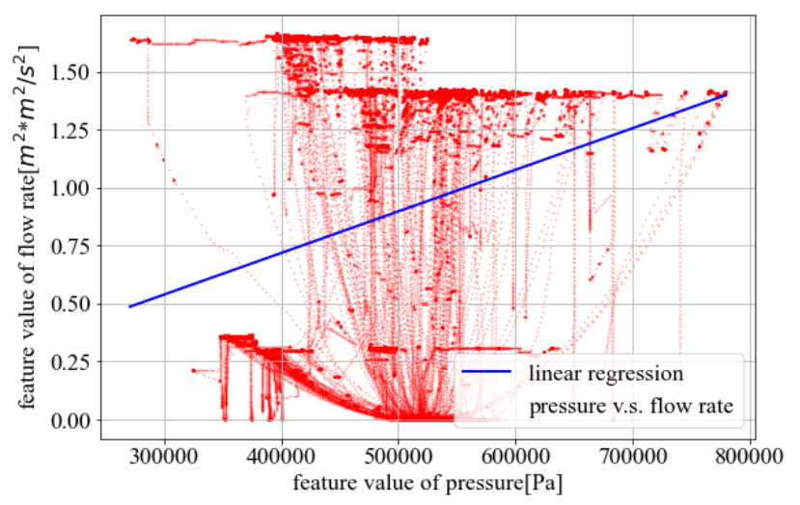  
**(a) $ρ/a^{2}$ Estimation Result (LVMWD Data)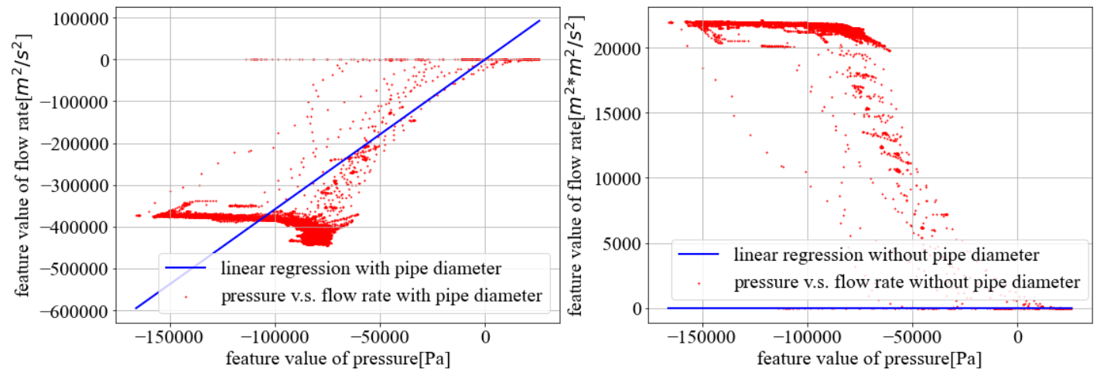 (b) $ρ$ Estimation Result (OCWD Data) (c) $ρ/a^{2}$ Estimation Result (OCWD Data)**

**Figure 2.7: Estimation Results of Unknown Parameters**

#### RO Optimization Simulation Model

* Summary

We formulated RO optimization problem for LVMWD and constructed a RO optimization simulation model implemented by the water quality prediction or fouling model. We will carry out the optimization simulation and calculate an improvement effect compared actual operation in the past period in the final report.

* RO Optimization Problem for LVMWD

We formulated the RO optimization problem for LVMWD. Basic optimization story for LVMWD is to decrease the chemical dosing cost (e.g., chloramines) while satisfying water quality standards or monitoring a RO membrane fouling. The problem is formulated as scheduling problem same as OCWD.

* Flow Chart

Figure 2.9 shows the flow chart for LVMWD based on the RO system configuration. The RO system configuration of LVMWD can be found in Additional Materials A2. Figure 2.9 (a) is the flow chart limited to the part related to permeate TOC prediction and Figure 2.9 (b) is the flow chart limited to the part related to permeate EC prediction.

In Figure 2.9, the arrows and objects are same meaning as the case of OCWD (in Figure 1.11). Especially, output data from the hexagon object toward the square object is calculated by the prediction model in the previous section.



1. **RO Total Flow Chart (Permeate TOC)**



1. **RO Each Stage Flow Chart (Permeate EC)**

**Figure 2.9: Flow Chart for RO Optimization Simulation (LVMWD)**

* Mathematical Optimization Problem

Optimization variable list is as shown in Table 2.4. “Optimization Variable”, “Fixed Parameter”, and “Intermediate Variable” have the same meaning as in the case of OCWD. In LVMWD optimization model, “Optimization Variable” is “UF Filtrate Total Chlorine” and the number of the optimization variables $n=1$.

**Table 2.4: Optimization Variable List (LVMWD)**

|  |  |  |  |
| --- | --- | --- | --- |
| ID No. | Description | Units | Opt. Variable / Fixed Parameter |
| ID0000 | UF Filtrate Total Chlorine | ton/day | Optimization Variable |
| ID0001 | Feed EC | $$μS/cm$$ | Fixed Parameter |
| ID0002 | Feed TOC | mg/L | Fixed Parameter |
| ID0003 | Feed Temperature | $$℉$$ | Fixed Parameter |
| ID0004 | Feed pH | - | Fixed Parameter |
| ID0100 | Stage 1 Feed Pressure | psi | Fixed Parameter |
| ID0101 | Stage 1 Feed Flow Rate | gpm | Fixed Parameter |
| ID0102 | Stage 1 Permeate Flow Rate | gpm | Fixed Parameter |
| ID0200 | Stage 2 Feed Flow Rate | gpm | Fixed Parameter |
| ID0201 | Stage 2 Permeate Flow Rate | gpm | Fixed Parameter |
| ID0300 | Stage 3 Feed Pressure | psi | Fixed Parameter |
| ID0301 | Stage 3 Feed Flow Rate | gpm | Fixed Parameter |
| ID1000 | Stage 1 Permeate EC | $$μS/cm$$ | Intermediate Variable |
| ID2000 | Stage 2 Feed EC | $$μS/cm$$ | Intermediate Variable |
| ID2001 | Stage 2 Permeate EC |  | Intermediate Variable |
| ID3000 | Stage 3 Feed EC | $$μS/cm$$ | Intermediate Variable |
| ID3001 | Stage 3 Permeate EC | $$μS/cm$$ | Intermediate Variable |
| ID4000 | Permeate TOC | mg/L | Intermediate Variable |

The objective function $f(x)$ is formulated as follows:

$$\begin{aligned}f(x) =\sum_{t=1}^{L}{(c_{1}x_{ID0000}\left[t\right])}\#\left(2.10\right)\end{aligned}$$

Here, $x_{ID0000}\left[t\right]$ denotes UF filtrate total chlorine at time $t$, $c_{1}$ denote cost coefficients, and $L$ denotes the length (step size) of optimization period, respectively.

Constraint conditions are as following:

$$\begin{aligned}1≤x_{ID0000}\left[t\right]≤2; t=1,2,…,L\#\left(2.11\right)\end{aligned}$$

$$\begin{aligned}0≤x_{ID1000}\left[t\right]≤50; t=1,2,…,L\#\left(2.12\right)\end{aligned}$$

$$\begin{aligned}0≤x_{ID2001}\left[t\right]≤50; t=1,2,…,L\#\left(2.13\right)\end{aligned}$$

$$\begin{aligned}0≤x_{ID3001}\left[t\right]≤60; t=1,2,…,L\#\left(2.14\right)\end{aligned}$$

$$\begin{aligned}0≤x_{ID4000}\left[t\right]≤0.15; t=1,2,…,L\#\left(2.15\right)\end{aligned}$$

$$\begin{aligned}-1≤x_{ID0000}\left[t\right]-x_{ID0000}\left[t+1\right]≤1; t=1,2,…,L-1\#\left(2.16\right)\end{aligned}$$

$$\begin{aligned}1≤γ_{ID1000}\left[t\right]≤2.5; t=1,2,…,L\#\left(2.17\right)\end{aligned}$$

$$\begin{aligned}1≤γ_{ID2001}\left[t\right]≤2.5; t=1,2,…,L\#\left(2.18\right)\end{aligned}$$

$$\begin{aligned}1≤γ_{ID3001}\left[t\right]≤2.5; t=1,2,…,L\#\left(2.19\right)\end{aligned}$$

$$\begin{aligned}1≤γ_{ID4000}\left[t\right]≤2; t=1,2,…,L\#\left(2.20\right)\end{aligned}$$

Here, Equations (2.11), (2.12), (2.13), (2.14), (2.15) denote lower and upper limit, Equation (2.16) denotes fluctuation range limit, Equations (2.17), (2.18), (2.19), (2.20) denote water quality standards limit based on LRV, respectively.

Intermediate variables $x_{ID1000}\left[t\right]$ (Stage1 permeate EC), $x_{ID2001}\left[t\right]$ (Stage2 permeate EC), $, x_{ID3001}\left[t\right]$ (Stage3 permeate EC), and $x_{ID4000}\left[t\right]$ (permeate TOC) are calculated by water quality prediction model as follows:

$$\begin{aligned}x_{ID1000}\left[t\right]=F_{ID1000}\left(x_{ID0000}\left[t\right],x_{ID0001}\left[t\right],x_{ID0003}\left[t\right],x_{ID0004}\left[t\right],x_{ID0100}\left[t\right],x_{ID0101}\left[t\right]\right); \\ t=1,2,…,L\#\left(2.21\right)\end{aligned}$$

$$\begin{aligned}x_{ID2001}\left[t\right]=F_{ID2001}(x_{ID0000}\left[t\right], x_{ID0003}\left[t\right],x_{ID0200}\left[t\right],x_{ID2000}\left[t\right]); t=1,2,…,L\#\left(2.22\right)\end{aligned}$$

$$\begin{aligned}x_{ID3001}\left[t\right]=F_{ID3001}\left(x_{ID0000}\left[t\right], x_{ID0003}\left[t\right],x_{ID0300}\left[t\right],x_{ID0301}\left[t\right],x_{ID3000}\left[t\right]\right); \\ t=1,2,…,L\#\left(2.23\right)\end{aligned}$$

$$\begin{aligned}x_{ID4000}\left[t\right]=F_{ID4000}(x_{ID0000}\left[t\right],x_{ID0001}\left[t\right],x_{ID0002}\left[t\right], x_{ID0003}\left[t\right],x_{ID0004}\left[t\right],x_{ID0100}\left[t\right], \\ x_{ID0101}\left[t\right],x_{ID0300}\left[t\right]); t=1,2,…,L\#\left(2.24\right)\end{aligned}$$

Here, each prediction model is shown in details as previous section. $γ_{X}$ is Logarithmic Reduction Value (LRV) of water quality data $X$ (e.g., electric conductivity and TOC) as Equation (1.33).

The scale of the above problem can be roughly estimated such as number of total optimization variables $N=L$ and number of total constraints . For example, if the optimization period is 1week of 30 minutes time interval data, we can estimate $L=48×7=336$ steps, $N=336$, and $K=10×336-1=3359$.

* Optimization Algorithm

We constructed and used the optimization algorithm by combination of SHADE and Feasibility Rule for solving the above constrained optimization problem same as the case of OCWD.

### Desktop Evaluation based on WBMWD

WBMWD receives secondary effluent from the City of Los Angeles’s Hyperion Water Reclamation Plant (HWRP)[6].

As WBMWD process flow schematic is shown in Figure 3.1. The secondary effluent is distributed to two streams; 40 MGD recycled water for industrial and irrigation as highlighted in yellow in the Figure, and another 45 MGD recycled water for cooling tower and boiler feed as highlighted in gray in the Figure 3.1.

The objective of data analysis is to maintain effluent turbidity less than 2 NTU required by the Title 22 criteria and to optimize ferric chloride and cationic polymer dosage for saving.

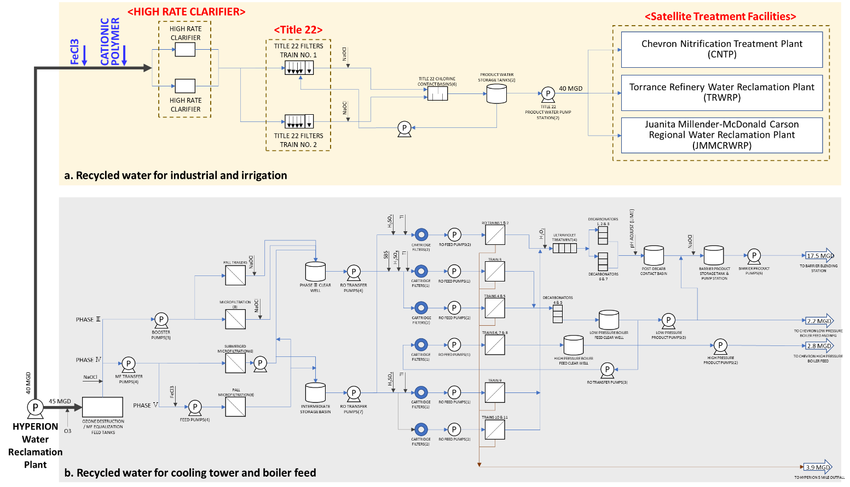

Figure 3.1: WBMWD Process Flow Schematic

#### Title 22 Requirements

Title 22 is California’s Code of Regulations which refers to the State guidelines for how treated and recycled water is discharged and used[7]. The water quality criteria for the four types of recycled water are defined by the Title 22 Code. In this data analysis, the criteria for turbidity should be considered and is defined as below[8].

* Criteria 1: Not exceed average turbidity of 2 NTU within a 24-hour period
* Criteria 2: Not exceed 5 NTU more than 5 percent of the time within a 24-hour period
* Criteria 3: Not exceed 10 NTU at any time

Considering Criteria 1, 2 and 3, daily average of Title 22 filter effluent turbidity, the number of times that turbidity exceeds 5 NTU and turbidity hourly average data were calculated with hourly data, respectively.

#### Target Process for Data Analysis and Measurement Points

* Target Process

The secondary effluent from HWRP is received by WBMWD and the recycled water for industrial and irrigation sent to three Satellite Treatment Facilities (Chevron Nitrification Treatment Plant, Torrance Refinery Water Reclamation Plant, and Juanita Millender-McDonald Carson Regional Water Reclamation Plant)4 that have MF and RO membranes systems. “HIGH-RATE CLARIFIER” and “Title 22” filter behaviors indicated by red in Figure 3.1 were investigated to optimize ferric chloride (FeCL3) and cationic polymer dosage.

Title 22 is a set of regulations in the California Code of Regulations. There are two types of tertiary media filters, Tittle 22 filters and converted Title 22 filters. The converted Title 22 filters have an anthracite bed as deep as 4 to 6 feet4.

In this process, FeCL3 and cationic polymer are injected before the HIGH-RATE CLARIFIER to meet the Title 22 criteria. On the other hands, residual FeCL3 affects the following MF and RO membranes clogged at the Satellite Treatment Facilities. More FeCL3 dosing than the adequate demand doesn’t lead to the Title 22 filter performance in terms of turbidity control as expected. In this analysis, we focused on turbidity behaviors and residual FeCL3 from Title 22 filter.

* Measurement Points

To analyze data for Title 22 filter, both online hourly and grab sampling daily data listed in Table 3.1 were provided. The data from “1” to “12” are online data from January 2020 through March 2023, and the data from “G1” to “G3” are grab sampling daily data from September 2020 through March 2023.

The measurement points of the data received indicates in Figure 3.2. The online data from “1” to “12” are hourly recorded in the High-Rate Clarifier and Title 22 filter, and the grab sampling daily data from “G1” to “G3” are turbidity to confirm performance of the High-Rate Clarifier.

Table 3.1: Data List





Figure 3.2: Measurement Points

#### Trend Charts

All online trends except for backwash clarifiers are illustrated in Figure 3 (a) to Figure 3 (i). Apparently different behaviors were observed in FeCL3 dosage, cationic polymer dosage, Title 22 filter effluent turbidity and other parameters from July to November 2021.

Over that period, suspended solids in secondary effluent from HWRP were carried over to WBMWD. It resulted in solids overloaded for the High-Rate Clarifier and Title 22 filter.



(a): Ferric Chloride Dosage (b): PTHRC 1 Influent Flow Rate



(c): PTHRC 1 Cationic Polymer Dosage (d): PTHRC 2 Influent Flow Rate



(e): PTHRC 2 Cationic Polymer Dosage (f): PTHRC 2 Influent Flow Rate



(g): Title 22 Product Water Pressure (h): Title 22 Product Ferric Concentration



(i): Title 22 Filter Effluent Turbidity

Figure 3.3: Trend Charts for Each Data (WBMWD)

#### Title 22 Behaviors

The daily average data of effluent turbidity from Title 22 filter exceeded 2 NTU 282 times in 1186 days, as shown in Figure 3.4 (a), if classified the data based on the Criteria 1.

Figure 3.4 (b) shows the number of times that effluent turbidity exceeded 5 NTU in a day if the Criteria 2 considered. It exceeded 5 NTU more than 5% of the time (1.2 times in a day) 21 times in 1186 days.

Figure 3.4 (c) shows online hourly data of turbidity from Title 22 filter, which no data that exceeded 10 NTU at any time.

We will optimize FeCL3 and cationic polymer dosages to meet the Title 22 criteria considering the Criteria 1 and 2. The effluent turbidity is to maintain less than 2 NTU required by the Title 22 criteria.



(a): [Title 22 Criteria 1] Turbidity Daily Average Data



(b): [Title 22 Criteria 2] The Number of Times that Turbidity Exceeds 5 NTU



(c): [Title 22 Criteria 3] Turbidity Hourly Average Data

Figure 3.4: Turbidity Trend Chart for Each Title 22 Criteria

#### Predicting Effluent Turbidity and Residual FeCL3 from Title 22 Filter

As a first step, we confirmed that effluent turbidity and residual FeCL3 from Title 22 filter could be predicted using both grab sampling daily and online hourly data by multiple regression analysis (MLR). They are MLR as in the case of OCWD and LVMWD model. The data were standardized. MLR and data standardization are shown in Additional Materials A3.

* Predicting Effluent Turbidity and Residual FeCL3 from Title 22 filter using Grab Sampling Daily Data

We calculated effluent turbidity and residual FeCL3 from Title 22 filter using grab sampling daily data by multiple regression analysis.

As shown in Figure 3.2, influent turbidity to Title 22 filter was not measured as online but grab sampling. The grab sampling daily data cannot be incorporated into the prediction based on online hourly data. However, we predicted effluent turbidity and residual FeCL3 from Title 22 filter to confirm the relationships of turbidity between influent and effluent of Title 22 filter.

Methods

The variables to predict effluent turbidity and residual FeCL3 are listed in Table 3.2. The data “a” through “f” are explanatory variables, and the data “g” and “h” are objective variables. All of them are online data except for turbidity in Title 22 filter influent.

Regarding the variable “a” and “b”, these are calculated values by influent flow rate multiplied by chemicals (FeCL3 and Cationic Polymer) to secure the correlation with effluent turbidity and residual FeCL3.

Table 3.2: Variables to Predict Effluent Turbidity and Residual FeCL3



Results

Learning period is from May 10th, 2022, to March 7th, 2023, that corresponds to the statuses below.

* + The correlation between influent turbidity to Title 22 filter (Average of “G2” and “G3” in Figure 3.2) and effluent turbidity from Title 22 filter (“9” in Figure 3.2) is positive. The scatter plot of the turbidity both influent and effluent of Title 22 filter shown in Figure 3.5, and find the correlation positive (R=0.47).
  + The correlation between FeCL3 and Cationic Polymer dosage against effluent turbidity are negative are negative as shown in Figure 3.6 (a) and Figure 3.6 (b), these correlation coefficients -0.27 and -0.62 are given, respectively. The model accuracy was evaluated from Feb in 2022 to April in 2022 by root mean squared error (RMSE).



Figure 3.5: Correlation between before / after Title 22 Turbidity



(a): Correlation between FeCL3 (b): Correlation between Cationic Polymer

and Effluent Turbidity from Title 22 and Effluent Turbidity from Title 22

Figure 3.6: Correlation between Chemicals and Effluent Turbidity from Title 22 (Daily)

* + Prediction Model Accuracy

Figure 3.7 shows prediction trend charts and accuracy of each prediction model. The yellow line is actual value and the blue line is predicted value.

Figure 3.7 (a) shows the prediction results of Title 22 filter Ferric Concentration. As a result of prediction by the multiple regression analysis, the model accuracy of Title 22 filter Product Ferric Concentration during the evaluation period was RMSE = 0.44.

Figure 3.7 (b) shows the prediction results of the effluent turbidity. As a result of the prediction by the multiple regression analysis, the model accuracy of Title 22 filter effluent turbidity was RMSE = 0.43.



(a): Title 22 Product Ferric Concentration



(b): Title 22 Filter Effluent Turbidity

Figure 3.7: Prediction Model Accuracy using Grab Sampling Daily Data

* Predicting Effluent Turbidity and Residual FeCL3 from Title 22 filter using Hourly Online Data

Effluent turbidity and residual FeCL3 from Title 22 filter were calculated using hourly online data by the multiple regression analysis.

Methods

The variables to predict effluent turbidity and residual FeCL3 are listed in Table 3.3. The data “a” through “f” are explanatory variables, and the data g and h are objective variables. All of them are online data.

Table 3.3: Variables to Predict Effluent Turbidity and Residual FeCL3



Results

Learning period is from April 27th, 2022, to May 7th, 2022, that corresponds to the status below.

* + The correlation between FeCL3 and Cationic Polymer dosage against effluent turbidity is negative as shown in Figure 3.8 (a) and Figure 3.8 (b), these correlation coefficients -0.62 and -0.39 are given, respectively.



(a): Correlation between FeCL3 (b): Correlation between Cationic Polymer

and Effluent Turbidity from Title 22 and Effluent Turbidity from Title 22

Figure 3.8: Correlation between FeCL3 and Cationic Polymer against Effluent Turbidity from Title 22 filter (Hourly)

* + The model accuracy was evaluated from Dec. 1st, 2021, to Dec. 8th, 2021, by RMSE.
  + Prediction of Model Accuracy

Figure 3.9 shows prediction trend charts and accuracy of each prediction model. The yellow line is actual value and the blue line is predicted value.

Figure 3.9 (a) shows the actual value and the predicted value of Title 22 filter Ferric Concentration. As a result of prediction by the multiple regression analysis, the model accuracy of Title 22 filter Product Ferric Concentration during the evaluation period was RMSE = 0.11.

Figure 3.9 (b) shows the actual value and the predicted value of Title 22 filter effluent turbidity. As a result of prediction by multiple regression analysis, the model accuracy of Title 22 filter effluent turbidity during the evaluation period was RMSE = 0.40.



(a): Title 22 Product Ferric Concentration



(b): Title 22 Filter Effluent Turbidity

Figure 3.9: Prediction Model Accuracy using Hourly Online Data

### Future Tasks

In the model creation for OCWD and LVMWD, we will continue to consider the combination machine learning model and concentration polarization model for RO membrane system. And we will simulate if chemicals can be reduced while predicting water qualities such as conductivity, TOC, etc. and detecting membrane fouling and scaling.

In the model creation for WBMWD, we proceed to the simulation to optimize FeCL3 and cationic polymer dosages to secure the Title 22 requirements.

### Additional Materials

#### A1) RO System Configuration (OCWD)

The data set provided to this team is for the 100 mgd system. We note that the capacity has recently been upgraded to 130 mgd. The full-scale RO membrane system in OCWD, for the longer running 100 mgd of capacity, consists of 21 RO units (3 RO units x 7 RO trains) and each unit has 5 MGD capacity. As OCWD reported in Figure A.1**[9]**, these 21 RO systems are being operated by different types of RO membranes. Current analysis focuses upon RO UNIT B01. As shown in the figure below, the membrane type of RO UNIT B01 is Filmtec BW30XFRLE installed in October 2020.

RO UNIT B01 is a 3-stage configuration, with flow rate, pressure, conductivity, and differential pressure measured as shown in the Figure A.2. 50 categories of data were provided including feed & permeate flow rate, feed & permeate water qualities (such as conductivity, TOC, turbidity), feed & permeate pressure, Xact, and chemical dosage. Tag name list in OCWD is shown in Table A.1.

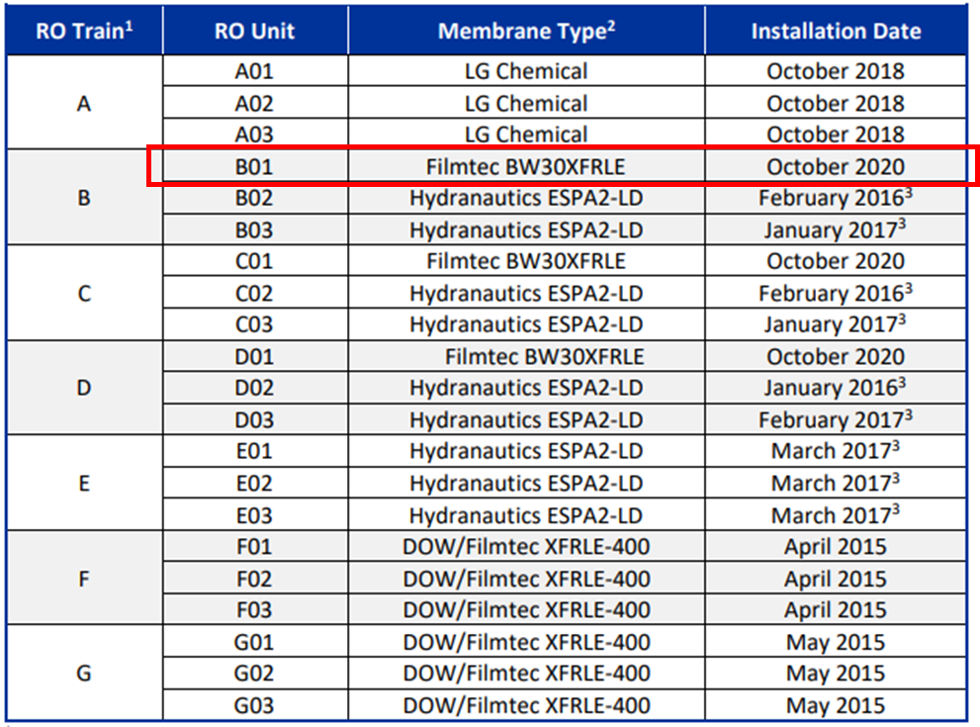

**Figure A.1: RO System Membranes (OCWD)**



**(a): The Whole RO System**



**(b): RO Unit B01 System**

**Figure A.2: RO System Configuration (OCWD)**

**Table A.1: Tag Name List (OCWD)**

|  |  |
| --- | --- |
| Tag Name | Variable Name |
| RO_B01 FW Press | RO B01 Feed Pressure |
| RO_Feed Cond | RO Feed EC |
| RO_01_FirstStageFeedFlow | RO Feed Flow Rate |
| RO_Feed Temperature | RO Feed Temperature |
| RO_Feed Ph | RO Feed pH |
| Sulfric Acid Usage | Sulfuric Acid Usage |
| Threshold Inhibitor Usage | Threshold Inhibitor Usage |
| RO_B01 FW B2 Press | RO B01 Feed Pressure |
| RO_01_SecondStageFeedConductivity | RO B01 Stage 2 Feed EC |
| RO_01_SecondStageFeedFlow | RO B01 Stage 2 Feed Flow Rate |
| RO_01_ThirdStageFeedConductivity | RO B01 Stage 3 Feed EC |
| RO_01_ThirdStageFeedFlow | RO B01 Stage 3 Feed Flow Rate |
| RO_Feed TOC | RO Feed TOC |
| RO_B01 Blank 1 Perm Cond | RO B01 Stage 1 Permeate EC |
| RO_B01 Blank 2 Perm Cond | RO B01 Stage 2 Permeate EC |
| RO_B01 Blank 3 Perm Cond | RO B01 Stage 3 Permeate EC |
| RO_Permeat TOC | RO Permeate TOC |

#### A2) RO System Configuration (LVMWD)

The RO membrane system in LVMWD is a pilot scale system. The RO system consists of 3-stage configuration, utilized the Toray TMG10D membrane, and is shown in the Figure A.3. Tag name list in LVMWD is shown in Table A.2.



**Figure A.3: RO System Configuration and Measurement Points (LVMWD)**

**Table A.2: Tag Name List (LVMWD)**

|  |  |
| --- | --- |
| Tag Name | Variable Name |
| PT_41095 | RO Stage 1 Feed Pressure |
| AIT_40006 | RO Feed EC |
| RO_01_FirstStageFeedFlow | RO Feed Flow |
| TIT_40005 | RO Feed Temperature |
| AIT_40008 | RO Feed pH |
| AI_31094 | UF Filtrate Total Chlorine |
| RO_01_SecondStageFeedConductivity | RO Stage 2 Feed EC |
| RO_01_SecondStageFeedFlow | RO Stage 2 Feed Flow |
| PT_41347 | RO Stage 3 Feed Pressure |
| RO_01_ThirdStageFeedConductivity | RO Stage 3 Feed EC |
| RO_01_ThirdStageFeedFlow | RO Stage 3 Feed Flow |
| AIT_40010 | RO Feed TOC |
| AIT_41092 | RO Stage 1 Permeate EC |
| AIT_41292 | RO Stage 2 Permeate EC |
| AIT_41392 | RO Stage 3 Permeate EC |
| AIT_41810 | RO Combined Permeate TOC |

#### A3) Mathematical Equations

Used mathematical equations for data analysis in this report are as follows:

* Multiple Linear Regression Model

Let $X={\left(x^{1},x^{2},…,x^{N}\right)}^{T}$ be the design matrix, $x^{i}={\left(x_{1}^{i},x_{2}^{i},…,x_{M}^{i}\right)}^{T}$ be the $i$-th explanatory vector, $y={\left(y^{1},y^{2},…,y^{N}\right)}^{T}$ be the predictive vector, and $(x^{i},y^{i})$ be the $i$-th training dataset.

In Multiple Linear Regression (MLR), the estimated parameters $\hat{w}={\left(\hat{w_{1}}, \hat{w_{2}},…,\hat{w_{M}}\right)}^{T}$ and $\hat{w_{0}}$ are shown as follows:

$$\begin{aligned}\hat{w}={\left(X^{T}X\right)}^{-1}X^{T}y\#\left(A1\right)\end{aligned}$$

$$\begin{aligned}\hat{w_{0}}=\overline{y}-(\hat{w_{1}}\overline{x_{1}}+\hat{w_{2}}\overline{x_{2}}+…+\hat{w_{M}}\overline{x_{M}})\#\left(A2\right)\end{aligned}$$

The standard coefficient ${\hat{w}}_{standard, j}$ is calculated by using the following equation:

$$\begin{aligned}{\hat{w}}_{standard, j}={\hat{w}}_{j}×\frac{std(x_{j})}{std(y)};j=1,2,…,M\#\left(A3\right)\end{aligned}$$

Here, $\overline{x_{j}},\overline{y}$ denote the average of $x_{j}^{i},y^{i}$ and $std\left(x_{j}\right),std\left(y\right)$ denote the standard deviation of $x_{j}^{i},y^{i}$, and they are calculated by using training dataset.

Moreover, the standardization of observation data $X$ is calculated by using the following equation:

$$\begin{aligned}X_{stand}\text{ = }\frac{X-\overline{X}}{std\left(X\right)}\#\left(A4\right)\end{aligned}$$

Here, $\overline{X}$ denote the average of $X$ and $std\left(X\right)$ denote the standard deviation of $X$.

* Prediction Evaluation Index

The prediction evaluation indexes are Mean Absolute Percentage Error (MAPE) $E_{MAPE}$ [%] and Root Mean Percentage Error (RMSE) $E_{RMSE}$. MAPE indicates a relative prediction error and RMSE is an absolute prediction error. They are formulated as follows: $$\begin{aligned}E_{MAPE}=\frac{100}{L}\sum_{t=1}^{L}{\frac{\left|y_{Pre}\left[t\right]-y_{Act}\left[t\right]\right|}{y_{Act}\left[t\right]}} [\%]\#\left(A5\right)\end{aligned} \\ \begin{aligned}E_{RMSE}=\sqrt{\frac{1}{L}\sum_{t=1}^{L}{{\left(y_{Pre}\left[t\right]-y_{Act}\left[t\right]\right)}^{2}}}\#\left(A6\right)\end{aligned}$$ 
Here, $y_{Act}\left[t\right]$ is the actual data and $y_{Pre}\left[t\right]$ is the predicted data at time $t$. $L$ is the length of the prediction period.

1. <https://wwwbrr.cr.usgs.gov/projects/GWC_chemtherm/software.htm>
2. R. Tanabe and A. Fukunaga: “Success-History Based Parameter Adaptation for Differential Evolution,” Proceedings of IEEE Congress on Evolutionary Computation 2013, pp.71–78 (2013)
3. K. Deb: “An Efficient Constraint Handling Method for Genetic Algorithms”, Computer Methods in Applied Mechanics and Engineering, Vol. 186 No. 2-4, pp.311-338 (2000)
4. The Black-box Optimization Benchmarking (BBOB) workshop (https://numbbo.github.io/workshops/)
5. G. Welch and G. Bishop: “An Introduction to the Kalman Filter”, Univ. of North Carolina (1995)  
   https://perso.crans.org/club-krobot/doc/kalman.pdf
6. Recycled Water Master Plan West Basin Municipal Water District ([West-Basin-Master-Plan_final_rev4.pdf (westbasin.org)](https://www.westbasin.org/wp-content/uploads/2022/05/West-Basin-Master-Plan_final_rev4.pdf))
7. WATER EDDUCATION FOUNDATION, WATER RECYCLING AND TITLE 22 (https://www.watereducation.org/aquapedia/water-recycling-and-title-22#:~:text=Title%2022%20of%20California's%20Code,water%20is%20discharged%20and%20used.)
8. Wastewater Treatment Plant Master Plan, APPENDIX D: TITLE 22 REQUIREMENTS (https://www.napasan.com/DocumentCenter/View/276/Appendix-D-Title-22-Requirements-PDF)
9. GWRS 2020 ANNUAL REPORT (https://www.ocwd.com/wp-content/uploads/2020-gwrs-annual-report-appendices-1.pdf)